[1]

A Robotic Arm for Cube Detection and Manipulation

Yi Chen, Da Li, and Zhen Wu

*Abstract*— This report presents a six degree-of-freedom (DOF) robotic arm (Rex-arm) with integrated acting, sensing and reasoning functionalities to autonomously grasp, align and stack cubes. A 2 DOF gripper is designed and fabricated by 3-D printing to perform grasping and releasing the cubes. Secondly, a Kinetic sensor (a RGB camera and a depth sensor) is calibrated and used to detect and localize the cubes. The accuracy of the sensing system is demonstrated to be 2.3 mm in RMSE. A motion planning algorithm incorporating solving inverse kinematic and generating intermediate way points is developed to perform pick and place of cubes. Last, a finite state machine is implemented to integrate each module to perform events specified user.

# Introduction

Robotic manipulators are electronically controlled mechanism, consisting of multiple segments that perform tasks by interacting with the environment. They have been widely adopted to perform industry specific tasks such as picking and placing objects [1]. In this report, we present a 6 Degree-of-Freedom (DOF) robotic arm to autonomously detect, pick, move, align and/or stack cubes. To realize the goal, we decompose the task into four major milestones: gripper design, sensing, kinematics and planning with finite state machine.

The report is organized as follows: Section II describes the overview of the experimental setup used in this study. Section III describes the method studied for path smoothing and its performance evaluation. Section IV describes the final design of the gripper, design trade-offs and improvements made during the course of study. Section V describes the method we adapted to perform camera calibration and the algorithm implemented to detect and locate cubes. Section VI describes the derivation of forward and inverse kinematics and Section VII describes the algorithm for motion planning and implementation of FSM. Finally, The results of competition are showed and discussed in Section VIII and IX respectively.

# Methodology

The experimental setup includes 4 Dynamixel AX-12A servo motors connected in series to form a 4 DOF robotic arm (i.e., Rexarm) as shown in Figure 1(a). The bottom servo motor is anchored on a 605mm by 605mm square board. Two additional XL320 motors are used to control the motion of the gripper. The motors are connected in series through Dynamixel adapter to power and serial port. Two XL320 motors are connected to a customized adapter board which lowers the voltage to 7.5V to control the motion of the gripper. A Kinetic sensor is placed over the board facing downwards and is used to sense the depth and RGB images of the board (Figure 1(b)).

To control the Rexarm, a control algorithm was written in Python to publish the command of desired angles to the servo motors and receive angular position and velocity measurements through the Dynamixel driver using Lightweight Communications and Marshalling (LCM) library. A detailed architecture of the software setup is shown in Figure 2 [2].



Figure 1. (a) Rexarm setup and (b) Kinect sensor setup

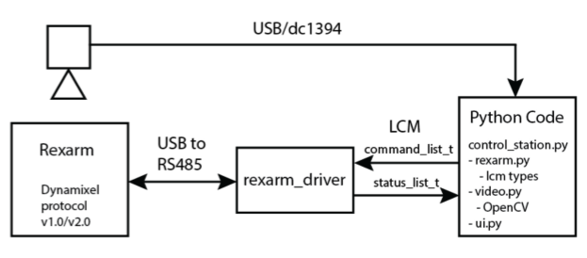

Figure 2. Architecture of the software setup

# Teach and repeat

For path smoothing, we implemented a quantic interpolation to get the position and velocity profiles between each pair of way points [2]. To evaluate the performance of path smoothing algorithm, we conducted experiments to compare the end-effector positions in world coordinates under four configurations by changing speed (low/high) and activating (or not activating) smoothing.

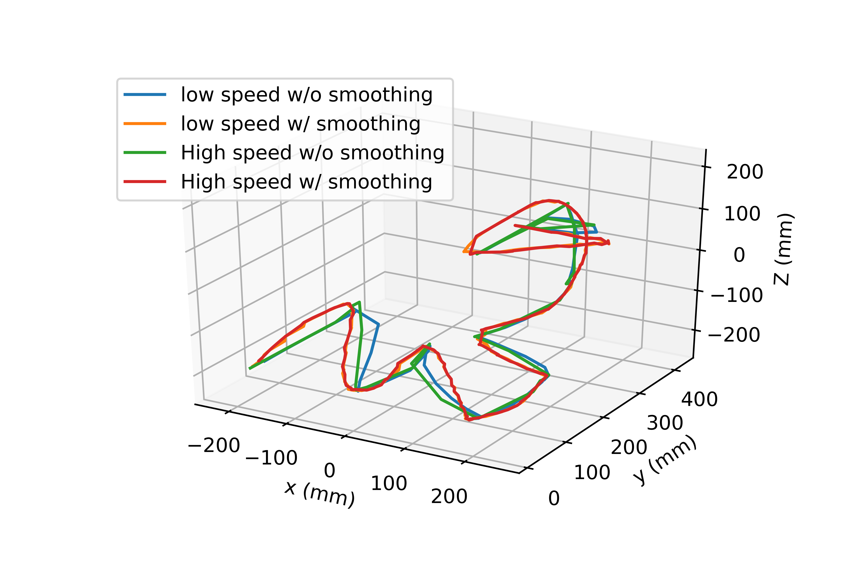

Figure 3. End-effector trajectories under four configurations

In the experiments, the teach-and-play functionality was implemented to record the way points generated by the prescribed end-effector positions, and the robotic arm was then set to repeat those way points under the aforementioned configurations. The joint angles and the world coordinates are recorded at a frequency of 20 Hz using the joint angle feedback and forward kinematics. The trajectories generated under these four configurations are shown in Figure 3. From this figure, we can see that the configuration of high speed with path smoothing will generate the smoothest trajectory.

The magnitudes of end-effector velocity for two configurations (high speed with/without path smoothing) were computed and shown in Figure 4. From this figure, we can see that when performing path smoothing, the magnitude of speed is much lower than that without smoothing.

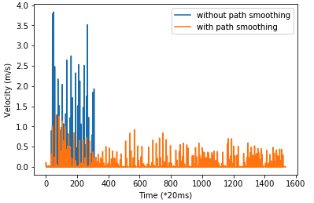

Figure 4. Magnitude of end-effector velocity under two configurations

# Gripper design

A two DOF gripper was designed to grasp and release a 38mm × 38mm × 38mm cubic block. As shown in Figure 5, the assembly of the gripper includes a pair of gripper hands, a rail, an ellipse, a rubber band, a connector and two XL-320 servo motors.

The two identical gripper hands were designed to grasp and release the target block. The basic geometry is an L-shaped structure, with the top part consisting flat contacting surfaces with a single layer of foam attached to increase the friction. The bottom part consists of several grooving features to install one or a few rubber bands used to pull the hands together. An ellipse is mounted on the output shaft of a XL-320 servo motor to convert the rotation of the shaft into a translation of the hands. The lengths of major and minor axes are carefully selected to ensure an adequate tolerance for the gripper to accommodate the block when fully opened, and fully engaged with the block while closed (Figure 5, lower left and lower right). A rail was designed to guide the translational motion of the gripper. In addition, a connector was also designed to connect another XL-320 motor to provide twisting motion, enabling one more DOF during the pick-and-place action.

The most important design choice was the open and close mechanism of gripper hands. We chose to use an ellipse, a rail and rubber bands as the open and close mechanism for the reason that the motor did not have to apply additional torque to clamp the block after grasping, which reduces the risk of dropping the block due to insufficient stall torque. During the experiments, the block was never dropped and therefore proved the design is effective in that regard.

There were other issues emerged during the assembly and usage of the gripper, and we managed to resolve them by making the following changes. All the details of the design can be found in Appendix D.

Length of major axis*:* The length of the major axis were increased from 45mm to 70mm after a few iterations to accommodate different orientations of the cube encountered during the grasping (diagonal of the cube), and to tolerate the error generated during the sensing, actuation. Nevertheless, the increased length of major axis also increased the possibility of interference between the ellipse and the board surface (Figure 5, lower right). This issue was resolved by introducing additional tolerance in solving the inverse kinematics.



Figure 5. Demonstration of grasp mechanism of the 3D printed gripper under different operation modes: fully open without block (upper left); fully closed without block (upper right); fully open with a block (lower left); closed gripper with a grasped block (lower right).

Bending rail: Constrained by the length of rivets (9 mm), the thickness of the rail is reduced to 2 mm, which caused the rail to bend during the pushing and pulling of gripper hands. Therefore, we introduced a curvature structure to support the rail, which resolved this issue.

Contacting of ellipse and rail: To eliminate the friction caused by the contacting between the lower surface of ellipse and the upper surface of rail, a 3 mm thick spacer was designed on the back of ellipse to create clearance.

# Methodology

## Path Planning

In this part, we develop a planner

The goal of computer vision task is to reliably detect the locations and the corresponding colors of the target cubes in the world coordinate. To do so, we first need to calibrate the Kinect to associate points in image coordinate (denoted by ${\left[u v 1\right]}^{T}$) with points in world coordinate (denoted by ${\left[x_{w} y_{w} z_{w} 1\right]}^{T}$) [3] [4]. According to the pinhole camera model, projective mapping from world coordinate to image coordinate can be expressed as [5] [6]:

$\left[\begin{matrix}u \\ v \\ 1\end{matrix}\right]=\frac{1}{Z(u,v)}K\left[\begin{matrix}I & 0\end{matrix}\right]\left[\begin{matrix}R & T \\ 0 & 1\end{matrix}\right]\left[\begin{matrix}x_{w} \\ \begin{matrix}\begin{matrix}y_{w} \\ z_{w}\end{matrix} \\ 1\end{matrix}\end{matrix}\right]=\frac{1}{Z(u,v)}K\left[\begin{matrix}I & 0\end{matrix}\right]H\left[\begin{matrix}x_{w} \\ \begin{matrix}\begin{matrix}y_{w} \\ z_{w}\end{matrix} \\ 1\end{matrix}\end{matrix}\right]$ (1)

where $K$ is the intrinsic matrix, $H$ is the extrinsic matrix and $z(u,v)$ is depth information at each pixel. From Eq.(1), the camera calibration process consists of three steps, i.e., identifying intrinsic matrix $K$, determining depth measurement function $z(u,v)$, and calibrating extrinsic matrix $H$.

Intrinsic matrix contains 5 parameters including focal length, camera sensor format, and principal point and is unique to each camera [5]. Its calibration is conducted by taking 10 screen shots from different orientations with an checkerboard. The calibrated intrinsic matrix is:

$$K=\left[\begin{matrix}520.77 & 0.0 & 316.38 \\ 0.0 & 519.22 & 252.46 \\ 0.0 & 0.0 & 1.0\end{matrix}\right]$$

Depth measurement function $z(u,v)$ associates the sensor reading from depth camera for pixel $(u,v)$ in RGB camera frame with actual physical height measured from board, direction z in Figure 1(b). To retrieve the correspondence, we first identified the relationship between the measurement $d$ using depth camera and height $z$. Figure 6 depicted the measured data and the corresponding fitted function using quadratic polynomial fit. For each known height, three measurements were taken at different locations of the board. The relation between $z$ and $d$ was then determined by fitting a second order polynomial using the least square method [7]. As shown in Figure 6, the fitted function resembled the trend of the measurements and the estimated depth function is $z\left(d\right)=-0.0043d^{2}+3.803d-505.36$ with $R^{2}=0.9992$. Raw data was documented in table A.1 in Appendix A for reference. However, since RGB and depth cameras were aligned side by side in the Kinetic sensor (Figure 1(a)), pixels in the depth image were not identical as those in the RGB image. Therefore, we conducted an affine transformation to align pixels between RGB and depth cameras [6]. The experiment setup and raw data were documented in Appendix A. With 12 correspondent location pairs, affine transformation from the depth image to RGB image and its counterpart (from RGB image to depth image) were determined to be: $\left[\begin{matrix}0.911 & -0.013 & 12.97 \\ 0.004 & 0.917 & 28.95\end{matrix}\right]$ and $\left[\begin{matrix}1.097 & 0.016 & -14.61 \\ -0.005 & 1.090 & -31.45\end{matrix}\right]$ respectively. We then obtained $z\left(u,v\right)$ for every pixel in the RGB image.

Lastly, we calibrated the extrinsic matrix using 16 points with known world coordinate values highlighted with cyan dot in Figure 7(a). The points were chosen to reflect a wide range of



Figure 6. Depth function to associate depth camera reading with actual height measured.

positions and depths and their values were documented in table A.3 in Appendix A. The corresponding coordinate of each point in camera frame was calculated using the calibrated intrinsic matrix and depth function. Detailed description of the algorithm to calculate extrinsic matrix is documented in Appendix A and it was determined to be:

$$H=\left[\begin{matrix}1.003 & -0.005 & 0.013 & 7.874 \\ -0.001 & 1.008 & -0.041 & 25.865 \\ 0.016 & -0.010 & -1.031 & 934.09 \\ 0 & 0 & 0 & 1\end{matrix}\right]$$

To verify the accuracy of the camera calibration procedure, we selected 11 points (Figure 7(b)) with known world coordinates and compared them with the measured world frame coordinates using the calibrated intrinsic, extrinsic matrices and depth function. Table 1 details the comparison. From the last column, we can calculate that the RMSE for $x$, $y$ and $z$ axis are 1.5mm, 2.7mm and 2.4mm respectively and the overall RMSE is 2.3mm. This error is less than 10% of the cube dimension (38 mm). Hence, using the proposed calibration procedure, we can achieve accurate location detection with the Kinetic sensor.



Figure 7. Setup for (a) extrinsic matrix calibration and (b) verification of the calibration accuracy

## Cube Detection

We decomposed the cube detection into two stages [8], i.e., location detection and color detection. For location detection, we identified the bounding boxes and the corresponding centroids using frames from depth camera. To eliminate outliers, we only considered boxes with an area greater than 300 and less than 1500. We then located the centroids of each candidate box to RGB camera for color detection. To detect color, we first created binary masks based on the HSV as well

TABLE 1

camera calibration accuracy

|  |  |  |  |
| --- | --- | --- | --- |
| # of points | Actual coord.  (x, y, z)[mm] | Measured coord.  (x, y, z)[mm] | Error  (x, y, z)[mm] |
| 1 | (200, -200, 38) | (199, -199, 42) | (-1, -1, 4) |
| 2 | (-200, -200, 76) | (-201, -201, 73) | (-1, -1, -3) |
| 3 | (-200, 0, 114) | (-200, 1, 111) | (0, 1, -3) |
| 4 | (-200, 200, 152) | (-204, 202, 148) | (-4, 2, -4) |
| 5 | (0, 200, 38) | (1, 201, 40) | (1, 1, 2) |
| 6 | (200, 200, 190) | (201, 202, 190) | (1, 2, 0) |
| 7 | (200, 0, 152) | (200, -2, 153) | (0, -2, 1) |
| 8 | (100, -100, 38) | (99, -93, 39) | (-1, 7, 1) |
| 9 | (-100, -100, 76) | (-98, -97, 76) | (2, 3, 0) |
| 10 | (-100, 100, 114) | (-100, 99, 116) | (0, -1, 2) |
| 11 | (100, 100, 152) | (100, 100, 152) | (0, 0, 0) |

as RGB channels for each candidate color using the training image provided in the class (Figure 8(a)) and validated and fine tuned the threshold using holdout images (Figure 8(b) and (c)). Then, we applied each mask to the RGB image for all the centroids. For robust detection, we created a small patch with 20 by 20 pixels around each centroid and calculated the probability of being each candidate color for the area. The final detected color was then selected to be the one with the highest probability. Detailed thresholds for each color were documented in Appendix B.

## Cube Detection

We decomposed the cube detection into two stages [8], i.e., location detection and color detection. For location detection, we identified the bounding boxes and the corresponding centroids using frames from depth camera. To eliminate outliers, we only considered boxes with an area greater than 300 and less than 1500. We then located the centroids of each candidate box to RGB camera for color detection. To detect color, we first created binary masks based on the HSV as well as RGB channels for each candidate color using the training image provided in the class (Figure 8(a)) and validated and fine tuned the threshold using holdout images (Figure 8(b) and (c)). Then, we applied each mask to the RGB image for all the centroids. For robust detection, we created a small patch with 20 by 20 pixels around each centroid and calculated the probability of being each candidate color for the area. The final detected color was then selected to be the one with the highest probability. Detailed thresholds for each color were documented in Appendix B.



Figure . (a), (b) and (c) Representative locations and color detection. (d) Confusion matrix for color detection using all validation and testing RGB images [9] shown in Appendix B.

Figure 8(a) to (c) depicted the detected color using the proposed probabilistic method, and it accurately predicted all but one color for various lighting conditions and cube positions. One misclassified color was in Figure 8(b) in which the algorithm predicted a red cube as pink which to some degree was also difficult for humane to distinguish. To further evaluate the robustness of the proposed method, we tested the algorithm with both validation images in Figure 8(b) and (c) and two additional testing images, documented in Appendix B, and presented the confusion matrix in Figure 8(d). Actual color was shown on vertical axis and the detected color was shown on horizontal axis. For each row, the probability was calculated by the number of cubes for each detected color divided by the total cube number for the given color. Hence, a higher probability on diagonal implies a better accuracy of prediction. As shown in Figure 8(d), our proposed method can reliably detect all colors but red for various lighting conditions and cube positions and is able to achieve a remarkably 100% accuracy for predicting black, orange, yellow, green and blue colors.

# Kinematics

We performed both forward and inverse kinematics analysis for the Rex-arm. The forward kinematics analysis determines the position and orientation of the end effector given the configuration of each individual joint, whereas the inverse kinematics problem determines the value for each join variable given the desired position and orientation of the end effector.

## Forward Kinematics (FK)

The coordinate frames for the Rex-arm are assigned according to the Denavit-Hartenberg (DH) convention as shown in Figure 9. Figure 10 (left) shows the schematic diagram of the Rex-arm. The Rex-arm is comprised of four revolute joints ($q_{0 }$ to $q_{3 }$) and four links ($a_{1 }$ to $a_{4}$). Frame $i$ is rigidly attached to link $i$ at joint $i+1$. The DH table of this configuration is shown in Table 2, where $a_{i}$ is the length of link $i$, and $θ_{i}$ is the angle of joint $i$. In the Rex-arm configuration, there are no link twist $α_{i}$ and link offset $d_{i}$. Therefore, these two columns are all 0 as shown in the table.

2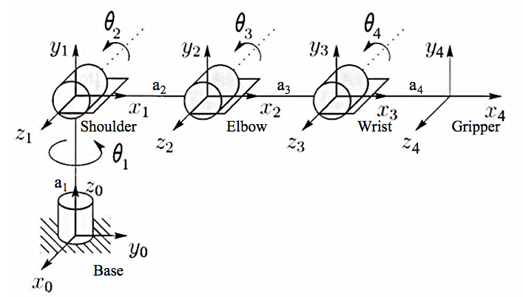

Figure 9.Coordinate frames for the Rex-arm

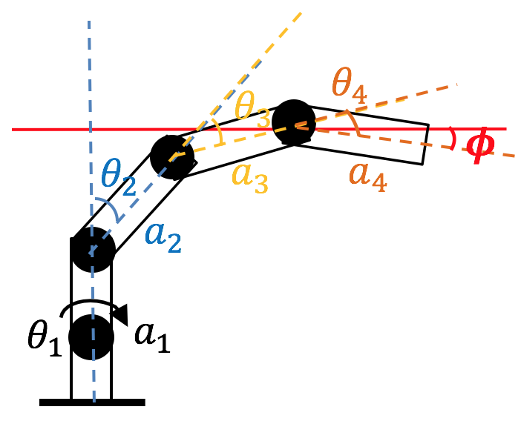

Figure 10. Schematic diagram of the Rex-arm (left) and IK analysis (right)

TABLE 2

DH table Rex-arm (length - $mm$, angle - degree)

|  |  |  |  |  |
| --- | --- | --- | --- | --- |
| Link | $$a_{i}$$ | $$α_{i}$$ | $$d_{i}$$ | $$θ_{i}$$ |
| 1 | $$130$$ | 0 | 0 | $$θ_{1}$$ |
| 2 | $$99$$ | 0 | 0 | $$θ_{2}$$ |
| 3 | 99 | 0 | 0 | $$θ_{3}$$ |
| 4 | 110 | 0 | 0 | $$θ_{4}$$ |

The transformation matrix $A_{i}$ (from frame $i-1$ to frame $i$) is represented as a product of four basic transformations [10].

$A_{i}={Rot}_{z, θ_{i}}{Trans}_{z, d_{i}}{Trans}_{x, a_{i}}{Rot}_{x, α_{i}}$ = $\left[\begin{matrix}\begin{matrix}c_{i} & {-s}_{i} \\ s_{i} & c_{i}\end{matrix} & \begin{matrix}0 & a_{i}c_{i} \\ 0 & a_{i}s_{i}\end{matrix} \\ \begin{matrix}0 & 0 \\ 0 & 0\end{matrix} & \begin{matrix} 1 & 0 \\ 0 & 1\end{matrix}\end{matrix}\right]$

where $c_{i}$ is $cosθ_{i}$, $s_{i}$ is $sinθ_{i}$. Therefore, the end effector position and orientation can be calculated using the homogeneous transformation:

$\left[\begin{matrix}x \\ y \\ \begin{matrix}z \\ 1\end{matrix}\end{matrix}\right]=A_{1}A_{2}A_{3}A_{4}\left[\begin{matrix}0 \\ 0 \\ \begin{matrix}0 \\ 1\end{matrix}\end{matrix}\right]$, $ϕ=\frac{π}{2}- θ_{2}- θ_{3}-θ_{4}$

where ${[x,y,z]}^{T}$ is the end effector position and $ϕ$ is the angle of end effector and the horizontal plane.

To verify the tooltip has achieved the expected workspace coordinates in FK. We recorded several workspace coordinates and the corresponding joint angle feedbacks. The end effector positions were calculated using the formula presented above. The root mean square errors were presented in Table 3 with an average value of 8.3 mm, which was acceptable compared to the block dimension of 38 mm.

## Inverse Kinematics

Given a desired position and orientation, IK calculates the angles of each joint in the Rex-arm. The steps for IK are described as follows (the angles are labeled in Figure 10 (right)):

Step 1 – calculate base rotation $θ_{1}$

$θ_{1}=atan⁡(x/y)$,

where x and y are the world coordinates of the desired end-effector location.

Step 2 – calculate the elbow rotation $θ_{3}$

$$θ_{3}=\arccos\left(\frac{∆z^{2}+ ∆r^{2}- {a_{2}}^{2}- {a_{3}}^{2}}{2a_{2}a_{3}}\right),$$

$∆z=z-a_{3}sinϕ-a_{1}$,

$∆r=x^{2}+ y^{2}-a_{3}cosϕ$,

Step 3 – Calculate the shoulder rotation $θ_{2}$

$$θ_{2}=\left\{\begin{aligned}\frac{π}{2}- β- ψ,if θ_{3}≥0 "elbow up" \\ \frac{π}{2}- β+ ψ, if θ_{3}< 0 "elbow down"\end{aligned}\right.$$

in which

$β=arctan⁡(∆z/∆r)$,

$$ψ=arccos⁡(\frac{∆z^{2}+ ∆r^{2}+ {a_{2}}^{2}- {a_{3}}^{2}}{2\sqrt{∆z^{2}+ ∆r^{2}}a_{2}})$$

Step 4 – Calculate the wrist rotation $θ_{4}$

$$θ_{4}=\frac{π}{2}-ϕ- θ_{2}- θ_{3}$$

TABLE 3

accuracy of forward kinematics (length - $mm$)

|  |  |  |  |  |  |  |  |
| --- | --- | --- | --- | --- | --- | --- | --- |
|  | Real coordinates (mm) | | | Calculated position (mm) | | | **RMSE (mm)** |
| No. | x | y | z | x | y | z |
| 1 | 0 | 200 | 0 | -3.9 | 189.1 | -5.3 | **12.7** |
| 2 | 100 | 200 | 0 | 93.3 | 191.4 | -3.6 | **11.5** |
| 3 | 200 | 100 | 0 | 192.9 | 96.9 | -0.8 | **7.8** |
| 4 | 200 | 0 | 0 | 192.2 | -3.2 | -1.5 | **8.6** |
| 5 | 200 | -200 | 0 | 198.7 | -198.0 | -1.4 | **2.8** |
| 6 | 0 | -200 | 0 | 2.7 | -194.0 | -5.8 | **8.8** |
| 7 | -200 | -200 | 0 | -195.4 | -203.9 | 2.4 | **6.5** |
| 8 | -200 | 0 | 0 | -193.6 | -7.6 | -6.4 | **11.8** |
| 9 | -100 | 100 | 38 | -97.5 | 86.3 | 34.2 | **14.4** |
| 10 | 100 | 200 | 38 | 99.1 | 196.1 | 37.3 | **4.1** |
| 11 | 200 | -100 | 38 | 201.1 | -101.0 | 39.2 | **1.9** |
| 12 | -100 | -100 | 38 | -102.1 | -105.7 | 37.5 | **12.7** |

# Finite state machine and motion planning

The system level integration for block detection (location and color), picking and placing decision, and gripping and arm movement are achieved using a finite state machine (FSM). A FSM is a math model used to represent one of a finite number of states of an abstract machine at any given time, with the transition of the state determined by output of the state [2]. In this application, the event of sensing, decision making, moving and grasp are inherently discretized states of the robot. Therefore a FSM is a natural solution to integrate the system and perform the given event.

## Overall design of FSM

As shown in Figure 11, there are 8 states in total to complete an event specified by the user. In a typical flow, state 1 receives the event number input by user, and starts the entire FSM. It is designed to incorporate the sensing module of the system to detect the location and color information of the blocks on the board. If no block is detected, the event is assumed to be over and the robot arm will be reset. Otherwise the information will be passed to state 2 to evaluate the board situation (event dependent). The state 2 will draw a conclusion if the event is over, Otherwise, the information regarding the blocks which need to be picked will be sorted out and passed to state 3. The state 3 will generate target locations for the given original locations, and prioritize the orders depending on the requirement of the event. Then, each block in the to-be-moved list needs to go through state 4 to state 7 to determine the inverse kinematic solution, generate way points, and to be moved to the target location. Finally the FSM will start another round of sensing and evaluating to decide to continue, until a max trial attempt is reached.



Figure 11. Schematic of finite state machine for system integration

We designed such architecture to ensure that the overall FSM is scalable to different events, once the rules are changed, one only needs to modify state 2 and state 3 to adapt to the new rules. The overall looping from state 1 to state 7 ensures that if any exception happens (unsuccessful grabbing, block dropped during transition, etc.), the FSM is able to re-evaluate the situation and start another round of pick and place.

During the internal test, we intentionally created unsuccessful pick and place by making the block dropped during the transition, and the robot was able to start new rounds of picking and place the block to the target place. Detailed explanation of FSM can be found in Appendix C.

## Motion planning for robot arm

During the task of moving block to its target location, it is crucial to plan the motion of the arms and the gripper in a sequential order to avoid collision between the robot and the blocks. After conducting a substantial amount of experiments with way point insertion and interpolation, trial and error with different gestures of pick and place, we decided to employ the following strategy for state 4 to state 6:

### State 4, solving inverse kinematics

For a given location of the block, two factors need to be determined to solve the inverse kinematics for the end effector: $ϕ$ and elbow orientation (up or down). To make the overall picking and placing gesture more natural and also reduce collision, we used the distance between the block and the center of the arm on the ground level, $d_{threshold}$, to determine how the arm should approach the block. When $d_{threshold}$ > 190 mm, the solution was solved with $ϕ$ = -15 $°$ and elbow down, whereas $d_{threshold}$ <= 190 result into solution with $ϕ$ = -90 $°$ and elbow up.

### State 5, generating way points

For each pair of initial pose and final pose of the end effector, one transitional pose was generated. For event 1 to 4, such pose was set to be the vertical position to avoid collision, and for event 5, it was set to be 30 mm above the target location to ensure the arm and the gripper would always move up first to create clearance from the built pyramids.

### State 6, motion planning

The execution of the motions of the robot is planned in a sequential order to avoid collision with other cubes. The overall sequence includes 1) moving to cube location, 2) grab cube, 3) move to a transition location, 4) move to the target location, 5) release cube, 6) move to a transition location. The detailed implementation and sequence can be found in Appendix C.

# Competition results and discussions

## Color detection

Despite the accurate prediction on colors using previous images [9], the threshold for color detection fails for most of the cases during contest. In fact, given the threshold, it predicts most of the color to be violet, as shown by the confusion matrix Figure 12. To generate the confusion matrixed, we placed each cube with a certain color on the board positions 1 to 8 as labeled in Figure 7(a) and took 5 measurements for each position. The probability was then calculated using the same method as before: the number of cubes for detected color divided by the total cube number for each color. We believe that the accuracy drop may be caused by the lightening condition change from our working station to the station on which sample images were taken. Therefore, to improve the detection accuracy, we propose to use the images captured from the stations one plans to work on under various lighting environments. Another potential alternative is to train a more robust color detection algorithm using Neural Network [11].



Figure 12. Confusion matrix for color detection during contest

## Overall Performance

In the final competition, we managed to finish the event 1 and event 2 with only one trial. We did not finish the event 3 and event 4 due to the issue of insufficient accuracy of color detection for the block. For event 5, we managed to pile 2 levels of pyramids in our internal test, but did not manage to tune the code robustly enough to accomplish higher level of pyramid building.

## Discussion on improvements

For future works, several action items can be done to potentially improve the performance:

1) The transition way points can be more customized for each event, so that the arm may move more efficiently. For example, in event 1 all the blocks are at the first level of height, therefore the transition points can be set the top of the block before picking. In this case, the arm does not have to move to the vertical position every time.

2) More testing and tuning for the color detection need to be done to produce a robust result to support the entire execution of event 3 and event 4.

# Conclusion

In this lab, a 6 DOF arm robot is designed and realized with three major modules, actuation, sensing and reasoning to pick cubic blocks and place them into specific positions.

In the realization of the actuation module, a 2 DOF gripper as end-effector is designed and fabricated by 3D printing. A forward and inverse kinematics modeling of the end-effector are derived and implemented.

The sensing module includes a Kinetic sensor mounted on top of the workstation. The camera and the depth sensor inside the Kinetic are first aligned using an affine transformation to retrieve depth information on each pixel in RGB camera frame. Calibrations for intrinsic and extrinsic matrices of the camera are then carried out to transform the pixel coordinate into the world coordinate. The experimental results show that the camera calibration achieves a RMSE of 2.3 mm. A block detection algorithm is also implemented to detect the centroids and the color of the cube. Due to the discrepancy of the lighting conditions between the training images and the actual workstation, the accuracy of the algorithm for color detection needs more fine tuning to achieve a satisfactory performance.

The reasoning module includes a FSM for system level integration and an algorithm for motion planning. The FSM uses the detected locations and color information of the blocks to evaluate the status of the events, compute target picking and placing locations for the blocks, and decide the order of the moving. For each block, the motion planner calculates the solution of inverse kinematics and interpolates waypoints between the initial and final poses, and executes the motion in a specific sequence to avoid collision.

Results of competition of event 1 and 2 demonstrate the final design and implementation is able to perform pick and place tasks. Future works include customizing the way points generation to improve the motion efficiency, and more tuning of color detection algorithm to adapt the lighting conditions and texture variations of the blocks on the workstation.

References

|  |  |
| --- | --- |
| [1] | E. Hall, Advances in Robot Manipulators, InTech, 2010. |
| [2] | "Introduction to ArmLab," ROB 550 Lab document. |
| [3] | J. Heikkila and O. Silven, "A four-step camera calibration procedure with implicit image correction," in *Computer Vision and Pattern Recognition*, San Juan, Puerto Rico, USA, 1997. |
| [4] | J. Weng, P. Cohen and M. Herniou, "Camera calibration with distortion models and accuracy evaluation," *IEEE Transactions on pattern analysis and machine intelligence,* vol. 14, no. 10, pp. 965-980, 1992. |
| [5] | D. A. Forsyth and J. Ponce, Computer Vision, A Modern Approach, Prentice HalL, 2003. |
| [6] | "ROB550 Robotic Systems Lab," ROB 550 Lab document. |
| [7] | B. S. Everitt and D. C. Howell, "Encyclopedia of Statistics in Behavioral Science," in *Least Squares Estimation*, John Wiley & Sons, 2005, pp. 1041-1045. |
| [8] | "Using OpenCV with Python," ROB 550 Lab document. |
| [9] | "Kinetic example images," ROB 550 Lab document. |
| [10] | M. W. Spong, S. Hutchinson and M. Vidyasagar, Robot modeling and control, New York: Wiley, 2006. |
| [11] | H. Altun, R. Sinekli, U. Tekbas, F. Karakaya and M. Peker, "An Efficient Color Detection in RGB Space Using Hierarchical Neural Network Structure," in *Innovations in Intelligent Systems and Applications (INISTA)*, Turkey, 2011. |

# Appendix A: camera calibration

## A.1 Depth function identification

Raw data used to identify the depth function $z(d)$ depicted in Figure 6.

TABLE A.1

data for depth function identification

|  |  |  |
| --- | --- | --- |
| # of points | Measured height  from board (z) [mm] | Depth camera  measurement (d) |
| 1 | 0 | 723 |
| 2 | 0 | 722 |
| 3 | 0 | 724 |
| 4 | 38 | 705 |
| 5 | 38 | 706 |
| 6 | 38 | 708 |
| 7 | 72 | 689 |
| 8 | 72 | 691 |
| 9 | 72 | 690 |
| 10 | 114 | 669 |
| 11 | 114 | 671 |
| 12 | 114 | 672 |
| 13 | 152 | 649 |
| 14 | 152 | 650 |
| 15 | 152 | 652 |
| 16 | 190 | 627 |
| 17 | 190 | 628 |
| 18 | 190 | 628 |
| 19 | 228 | 601 |
| 20 | 228 | 603 |
| 21 | 228 | 603 |

## A.2 Depth and RGB camera association

Setup image for depth and RGB camera association, dots are the positions used for calculation and detailed pixels values in RGB and depth camera are documented in Table A.2 below.



TABLE A.2

data for depth and RGB camera association

|  |  |  |
| --- | --- | --- |
| # of points | RGB camera  (x, y) | Depth camera  (x, y) |
| 1 | (144, 93) | (147, 70) |
| 2 | (140, 448) | (147, 456) |
| 3 | (204, 211) | (211, 196) |
| 4 | (203, 270) | (210, 260) |
| 5 | (201, 325) | (210, 326) |
| 6 | (321, 155) | (340, 133) |
| 7 | (318, 387) | (340, 389) |
| 8 | (435, 211) | (468, 197) |
| 9 | (434, 268) | (470, 259) |
| 10 | (436, 330) | (471, 325) |
| 11 | (498, 93) | (530, 69) |
| 12 | (499, 450) | (538, 456) |

## A.3 Extrinsic matrix calibration

TABLE A.3

data for extrinsic matrix calibration

|  |  |  |  |
| --- | --- | --- | --- |
| # of points | World coord.  (x, y, z)[mm] | # of points | World coord.  (x, y, z)[mm] |
| 1 | (200, -200, 0) | 9 | (100, -100, 152) |
| 2 | (0, -200, 38) | 10 | (0, -100, 38) |
| 3 | (-200, -200, 76) | 11 | (-100, -100, 76) |
| 4 | (-200, 0, 114) | 12 | (-100, 0, 114) |
| 5 | (-200, 200, 0) | 13 | (-100, 100, 152) |
| 6 | (0, 200, 38) | 14 | (0, 100, 38) |
| 7 | (200, 200, 76) | 15 | (100, 100, 76) |
| 8 | (200, 0, 114) | 16 | (100, 0, 114) |

Algorithm for extrinsic matrix calibration:

With both intrinsic matrix and depth function, Eq. (1) can be written as

$\left[\begin{matrix}x_{c} \\ \begin{matrix}\begin{matrix}y_{c} \\ z_{c}\end{matrix} \\ 1\end{matrix}\end{matrix}\right]=\left[\begin{matrix}R & T \\ 0 & 1\end{matrix}\right]\left[\begin{matrix}x_{w} \\ \begin{matrix}\begin{matrix}y_{w} \\ z_{w}\end{matrix} \\ 1\end{matrix}\end{matrix}\right]=H\left[\begin{matrix}x_{w} \\ \begin{matrix}\begin{matrix}y_{w} \\ z_{w}\end{matrix} \\ 1\end{matrix}\end{matrix}\right]$ (A.1)

where the only unknown is the extrinsic matrix $H$ that describes the coordinate transformation from 3D world frame (${\left[x_{w} y_{w} z_{w} 1\right]}^{T}$) to 3D camera frame (${\left[x_{c} y_{c} z_{c} 1\right]}^{T}$). Hence, the dimensions for $R$ and $T$ matrices in Eq. (A.1) are 3 by 3 and 3 by 1 respectively. This implies that there are a total of 12 parameters to be estimated to reconstruct the extrinsic matrix. For a pair of known correspondence, we have three equations

$\left[\begin{matrix}x_{c}^{i} \\ y_{c}^{i} \\ z_{c}^{i}\end{matrix}\right]=\left[\begin{matrix}a & b & \begin{matrix}c & d\end{matrix} \\ e & f & \begin{matrix}g & h\end{matrix} \\ \begin{matrix}i \\ 0\end{matrix} & \begin{matrix}j \\ 0\end{matrix} & \begin{matrix}\begin{matrix}k & l\end{matrix} \\ \begin{matrix}0 & 1\end{matrix}\end{matrix}\end{matrix}\right]\left[\begin{matrix}x_{w}^{i} \\ y_{w}^{i} \\ z_{w}^{i}\end{matrix}\right]$ (A.2)

where the superscript $i$ indicates the $i^{th}$ pair. For parameter estimation, Eq.(3) can be rearranged as

$\left[\begin{matrix}x_{c}^{i} \\ y_{c}^{i} \\ z_{c}^{i}\end{matrix}\right]=\left[\begin{matrix}x_{w}^{i} & y_{w}^{i} & z_{w}^{i} & 1 & 0 & 0 & 0 & 0 & 0 & 0 & 0 & 0 \\ 0 & 0 & 0 & 0 & x_{w}^{i} & y_{w}^{i} & z_{w}^{i} & 1 & 0 & 0 & 0 & 0 \\ 0 & 0 & 0 & 0 & 0 & 0 & 0 & 0 & x_{w}^{i} & y_{w}^{i} & z_{w}^{i} & 1\end{matrix}\right]β^{T}$ (A.3)

where $β=\left[\begin{matrix}a & b & c & d & e & f & g & h & i & j & k & l\end{matrix}\right]$ consists of the parameters in extrinsic matrix. With multiple pairs of known correspondences [7], we can expand Eq.( A.3) as

$$\left[\begin{matrix}x_{c}^{1} \\ ⋮ \\ z_{c}^{N}\end{matrix}\right]=\left[\begin{matrix}x_{w}^{i} & y_{w}^{i} & z_{w}^{i} & 1 & 0 & 0 & 0 & 0 & 0 & 0 & 0 & 0 \\ ⋮ & ⋮ & ⋮ & ⋮ & ⋮ & ⋮ & ⋮ & ⋮ & ⋮ & ⋮ & ⋮ & ⋮ \\ 0 & 0 & 0 & 0 & 0 & 0 & 0 & 0 & x_{w}^{N} & y_{w}^{N} & z_{w}^{N} & 1\end{matrix}\right]β^{T}=Aβ^{T}$$

and parameter $β$ can be determined using least square estimation $β^{T}={\left(A^{T}A\right)}^{-1}A^{T}y$, where $y={\left[\begin{matrix}x_{c}^{1} & … & z_{c}^{N}\end{matrix}\right]}^{T}$

# Appendix block detection

Training image

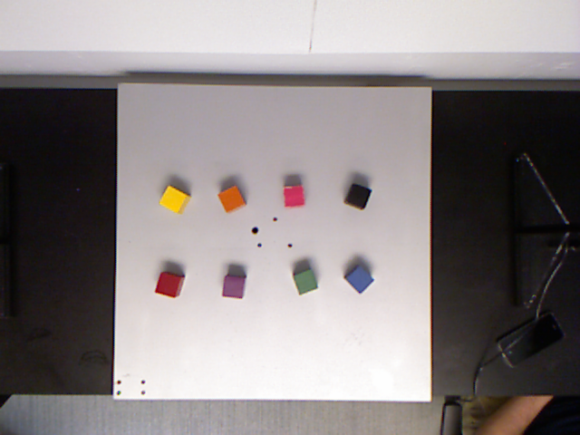

Validation images

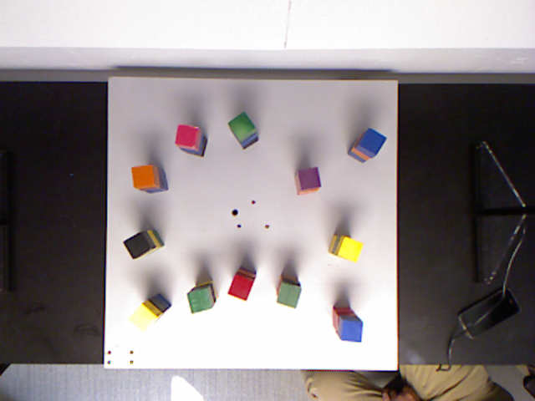

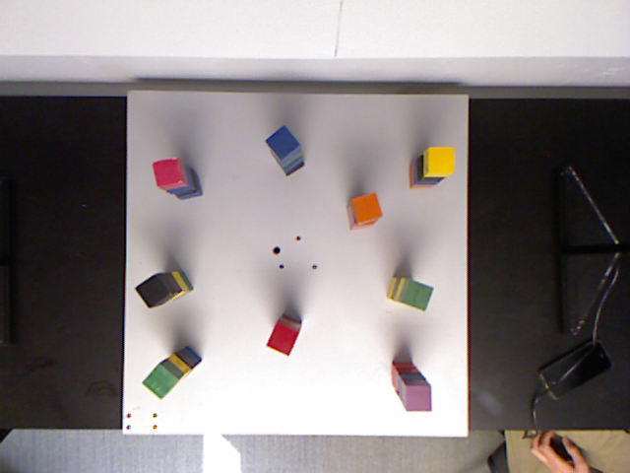

Testing images

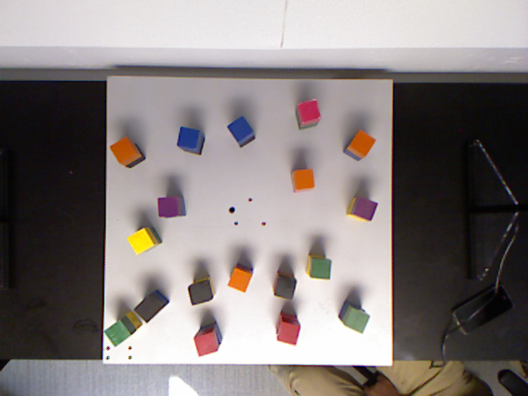

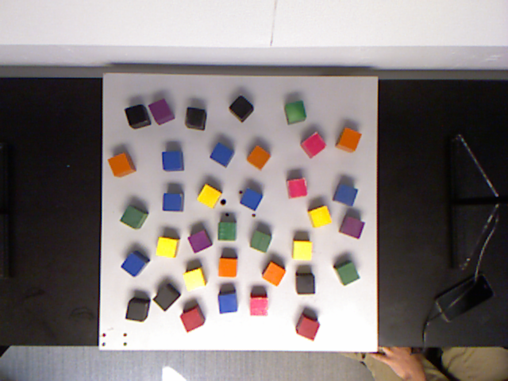

TABLE B.1

color thresholds

|  |  |  |  |  |
| --- | --- | --- | --- | --- |
| Color | H | S | V | L |
| Black | (0, 255) | (0, 80) | (0, 90) | (0, 100) |
| Red | (150, 200) | (100, 200) | (0, 255) | (0, 100) |
| Orange | (10, 40) | (0, 255) | (0, 255) | (0, 255) |
| Yellow | (20, 30) | (0, 255) | (0, 255) | (0, 255) |
| Green | (40, 100) | (0, 255) | (0, 255) | (0, 255) |
| Blue | (80, 130) | (0, 255) | (0, 255) | (0, 255) |
| Violet | (100, 140) | (0, 255) | (0, 255) | (0, 255) |
| Pink | (120, 255) | (0, 255) | (0, 255) | (120, 255) |
| Color | R | G | B |  |
| Black | (0, 255) | (0, 255) | (0, 255) |  |
| Red | (0, 255) | (0, 100) | (0, 100) |  |
| Orange | (125, 255) | (60, 140) | (0, 50) |  |
| Yellow | (0, 255) | (150, 255) | (0, 255) |  |
| Green | (0, 150) | (50, 255) | (0, 255) |  |
| Blue | (10, 100) | (0, 255) | (100, 255) |  |
| Violet | (100, 255) | (0, 255) | (100, 255) |  |
| Pink | (180, 255) | (0, 150) | (0, 255) |  |

# Appendix c: finite state machine design

## Detailed finite state machine

|  |
| --- |
| **Run_state_machine(event_num):** n_trial = 0 **Detecting all the blocks on the board:** Generate a color_list, loc_list  if no block detected:  to state 8  else:  to state 2 **Analyzing board situation based on event_num:** According to rules specified by event, identify the blocks need to be picked  If no block need to be picked or n_trial > n_max :  to state 8  else:  generate color_list_pick, loc_list_pick from color_list, loc_list **Generating target locations, assign orders:** For i = 1 to N in loc_list_pick:  compute loc_list_place[i]  Reorder loc_list_pick, loc_list_place according to its color info (only for event 3 and 4), to state 4  For i = 1 to N in loc_list_pick: **Compute solution of inverse kinematic:** Compute solution of inverse kinematic given loc_list_pick[i], loc_list_place[i]:  If no solution exists:  to state 7  else:  Compute angle_pick, angle_place then to state 5 **Generating way points:** Given angle_pick, angle_place, generates angle_transition for the arm, then to state 6 **Move one block to target location:** Given the way points, perform sequential movements on the arm and the gripper to pick and place the block **Checking if all blocks have been moved:** If all blocks have been moved:  n_trial += 1  to state 1  else:  to state 4  endfor **Terminate the event and reset arm position:** Close gripper and reset arm position to vertical pose  Return status of the event |

## Detailed Motion Sequence

For simplicity, the motors are abbreviated as: B (base), S (shoulder), E (elbow), W (wrist), G1 (grip1), G2(grip2). We define the following motion as:

Open gripper: G2 = 90 $°$

Close gripper: G2 = 0 $°$

Rotate gripper: G1 = 15 $°$ or -75 $°$

Lift to safety: move S 50 $°$ towards 0 $°$ direction

Move to pick: move the arm in sequence of B->E->S->W

Move to place: move the arm in sequence of B->S->E->W

Move at same: move B, S, E, W at same time to target

For event 1 to event 4, the motion plan is set to be: open gripper -> move to pick -> close gripper -> lift to safety -> move to transition -> move to place -> open gripper -> lift to safety -> move to transition

For event 5, the motion plan is set to be: open gripper -> move to pick -> close gripper -> lift to safety -> move to transition -> rotate gripper -> move to place -> open gripper -> move at same to transition -> move to transition

The designed motion plan was able to accomplish pick and place of block without generating interference with other objects during the experiments.

# Appendix d: cad drawing

Connector

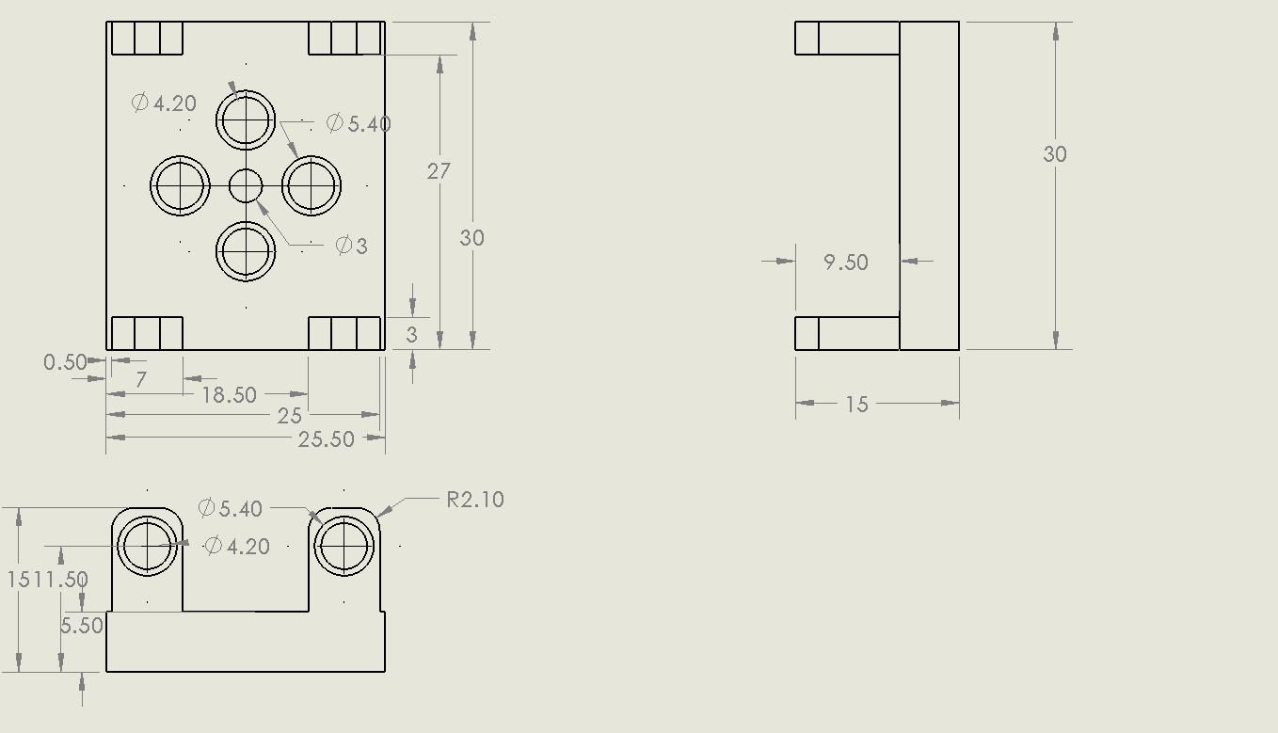

Ellipse with spacer

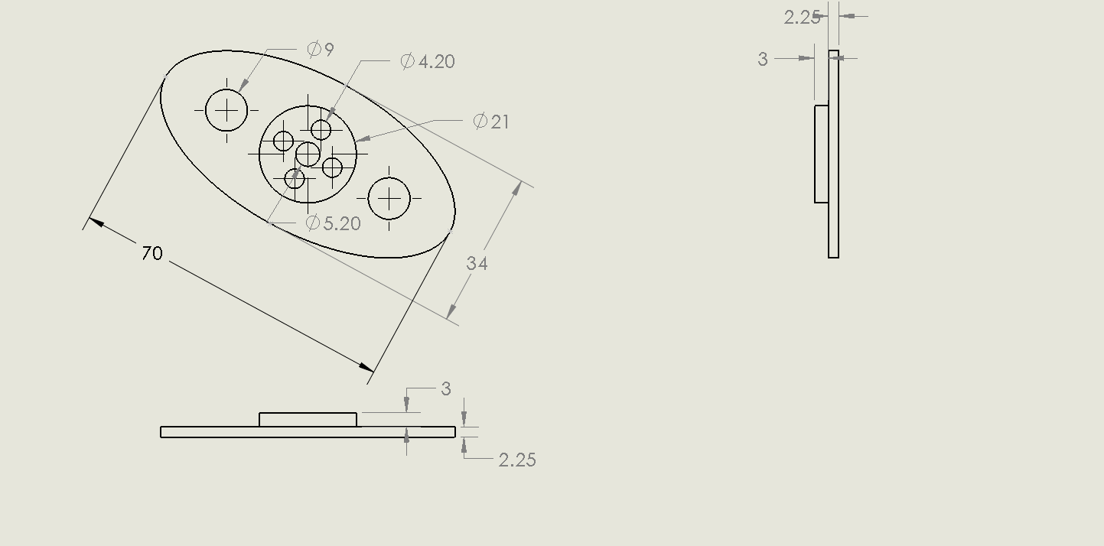

Gripper hand

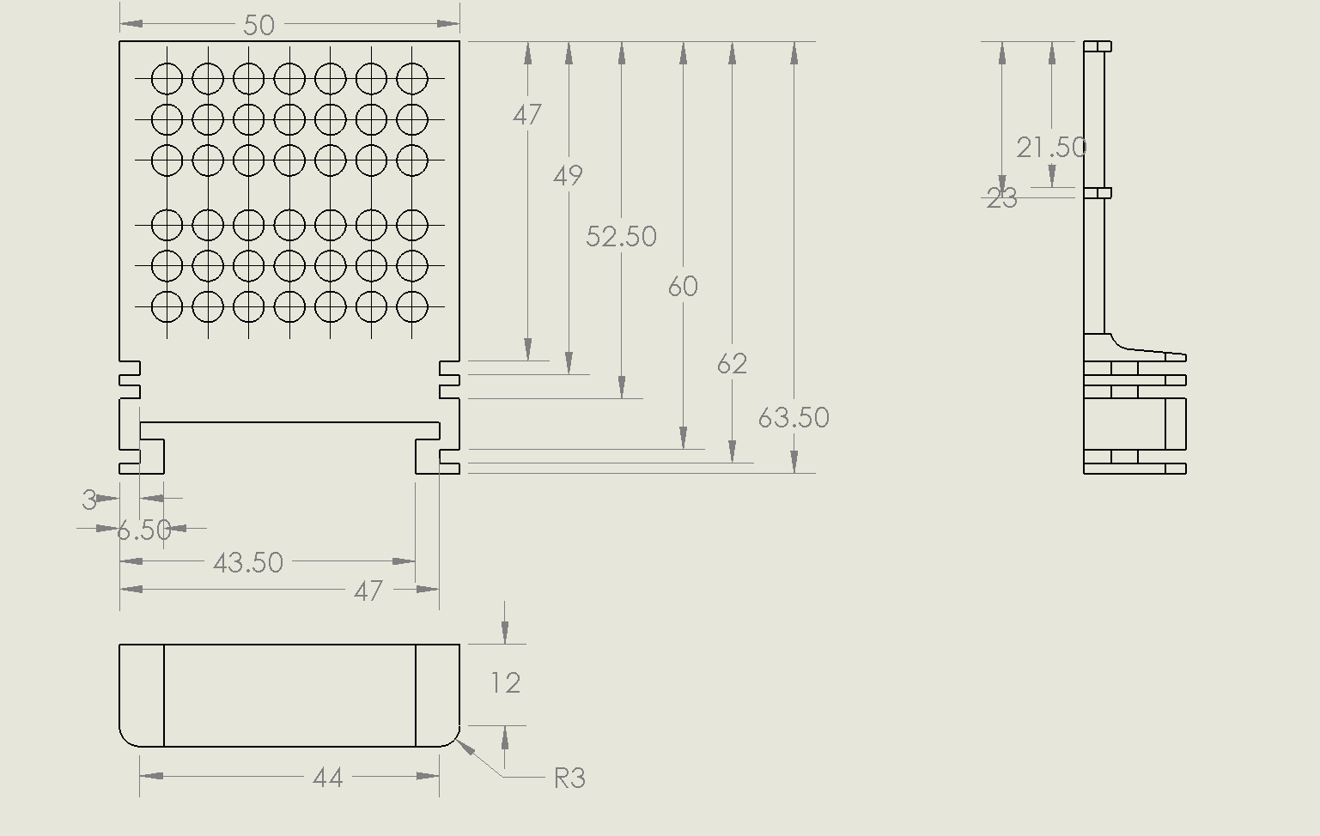

Rail

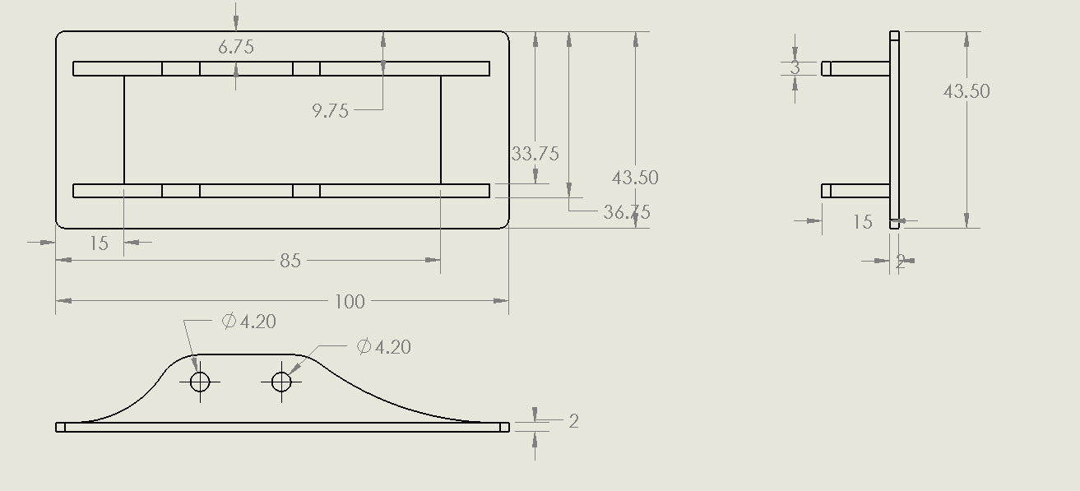

1.